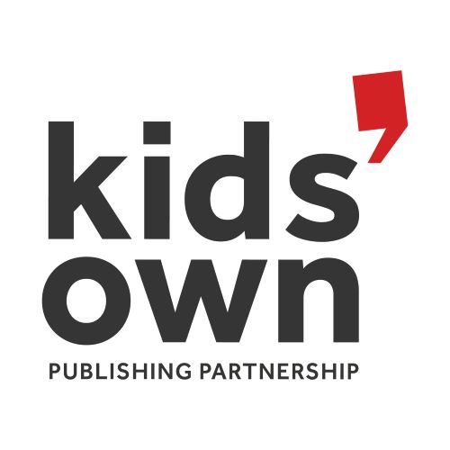

Kids' Own Visual Thinking Team

Application form for participation in an online visual thinking project to develop an exhibition of children’s artwork and writing from the Kids’ Own archive.

Kids’ Own has a special opportunity for young people, aged 10–13, to participate in an online visual thinking initiative.

Working alongside artist/curator Vanya Lambrecht Ward, young participants will have a special role in supporting and shaping the development of a new exhibition featuring artwork and writing from Kids’ Own’s extensive 23-year archive. Over a series of 6 online sessions, the team will explore aspects of the Kids’ Own archive – our books, our way of working, and visual art processes before selecting artwork and writing for the exhibition, as well as thinking about physical spaces of the exhibition and ways of presenting work for young audiences.

Please read the full call for participants/ project description before completing this form

About you

Name: ___________________________________________________________________________
Date of birth: ________________________________

What county do you live in? ________________________________

Tell us a little bit about yourself. What interests you most about this project?

Why do you think children’s artwork and writing is important?

For Parents/Guardians

Parent/Guardian Name: _________________________________

If selected, I consent to my child taking part in this online project (please see separate consent form and project information guide).

YES [ ] NO [ ]

I confirm that my child meets the essential criteria: [ ]

Consent and Contact details for Parent/Guardian

Parent/Guardian Name: _______________________________________

Relationship to child: _________________________________________

Mobile Number: __________________________________

Email address: _____________________________________________________

If selected to participate in this project, please give us an indication of times/ days suit you/your child best for online sessions:

Morning [ ]
Afternoon [ ]
Weekdays [ ]
Weekends [ ]
If selected for the project, you will be asked to pay €35 to Kids’ Own via PayPal or with a credit card over the phone. Kids’ Own has a strong ethos of equal access and inclusion. Please contact us if the participation fee is prohibitive for you.

Please complete and return this form, including your parent or guardian’s consent above to Ciara@kidsown.ie by Friday the 14th of May 2020.

Places are limited for this opportunity, but you can stay informed of further opportunities by subscribing to our newsletter on the homepage of our website: www.kidsown.ie

